**Ephraim Yacht Club**

**420 Regatta / Rich Hall Junior Regatta**

**Sailing Instructions**

**June 28th – June 29th, 2025**

1. **APPLICABILITY; RULES.**
   1. The regatta will be governed by the rules as defined in the current version of the Racing Rules of Sailing (RRS).
   2. RRS 63.7 shall be replaced by – “If there is a conflict between the Notice of Race (NOR) and the Sailing Instructions (SIs), the Sailing Instructions shall apply.” This changes RRS 63.7.
   3. Any competitor may protest under the rules in Attachment A.

1. **NOTICES.**

Notices to competitors will be posted on the official noticeboard located at the EYC.

1. **SIGNALS MADE ASHORE.**

Signals made ashore will be displayed from the flagpole located at the EYC. If a postponement is signaled ashore, the warning signal will be made not less than 30 minutes after flag AP is lowered. This changes Race Signals AP.

1. **SCHEDULE OF RACES.**

|  |  |
| --- | --- |
| Friday, June 21st |  |
| 12:00 Noon | Early Registration Deadline |
|  |  |
| Saturday, June 28th |  |
| 11:00 – 11:30 a.m. | Late Registration and Competitor Check-in |
| 11:30 a.m. | Boat draw for EYC members |
| 11:45 a.m. | Skipper’s meeting |
| 1:00 p.m. | Warning signal for the first race. |
| 4:00 p.m. | No warning signal after this time |
|  |  |
| Sunday, June 29th |  |
| 10:00 a.m. | Skippers Meeting |
| 11:00 a.m. | Warning signal for the first race. |
| 3:00 p.m. | No warning signal after this time |
|  |  |
| Following Scoring | Awarding of prizes at the EYC |

1. **RACING AREA.**

The racing area will be Eagle Harbor, Ephraim, Wisconsin, in the vicinity of the EYC.

1. **COURSES AND MARKS.**

Exhibit A shows the courses, course designations, the marks in order and the rounding direction of each mark. Courses will be designated either on a whiteboard on the Race Committee boat, or verbally by the Race Committee. Competitors should sail past the committee boat prior to each race to ask the course. All marks will be pink, orange, or yellow inflatable buoys.

1. **STARTING SEQUENCE.**

The three-minute sound-signals-only starting sequence shall be used:

|  |  |
| --- | --- |
| **Sound Signal** | **Time** |
| At least five short | [no specific time; competitors are alerted to upcoming three-minute signal] |
| Three long | 3 minutes |
| Two Long | 2 minutes |
| One long and three short | 1 ½ minutes |
| One long | 1 minute |
| Three short | 30 seconds |
| Two short | 20 seconds |
| 1 short | 10 seconds |
| 1 short | 5, 4, 3, 2 and 1 seconds |
| One long | Start |

1. **STARTING AND FINISHING LINES; SIGNALS.**

The starting and finishing lines will be between a staff on a Race Committee boat flying an orange flag or an "RC" flag, and a pink, orange, or yellow inflatable buoy. Individual recalls will be signaled by hail from the race committee, and no code flag "X" is required to be flown for individual recalls.

1. **TIME LIMIT.**

The time limit for each race will be 45 minutes for the first boat to sail the course in accordance with RRS 28.1.

1. **PROTESTS.**

Protests shall be delivered to a member of the Race Committee not later than one hour after the Race Committee boat has returned to the EYC pier after the last race that day. The Race Committee or other EYC staff, in consultation (when possible) with the Race and Regattas

Committee Chairman shall serve as judge(s) and hearings will be held as soon as possible at the EYC.

1. **SCORING.** 
   1. The Low Point Scoring System, RRS Appendix A will apply, except that no score will be excluded. This changes RRS A2.
   2. Up to five races are scheduled. One race shall constitute a Regatta.
2. **SAFETY** 
   1. **Decision to Race**. Competitors are reminded that they alone are responsible for deciding whether to race or to continue to race. Parents of competitors who are minors are responsible for deciding whether their children should race or continue to race.
   2. **Personal Floatation Devices.** Competitors are required to always wear PFDs when on the water.

EXHIBIT A

# COURSES

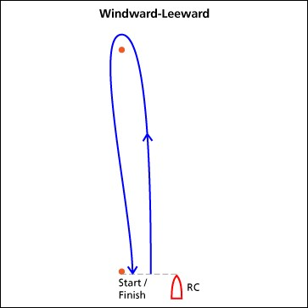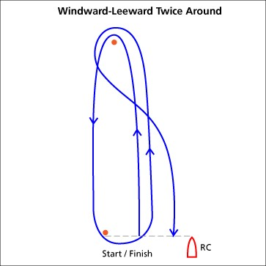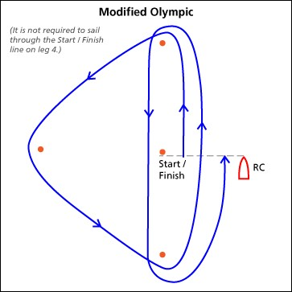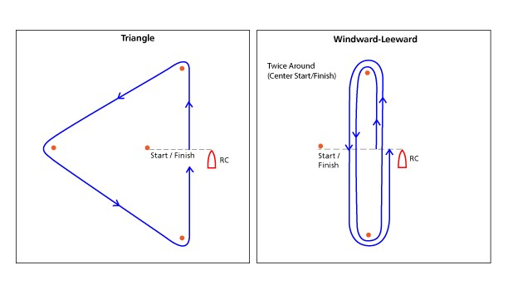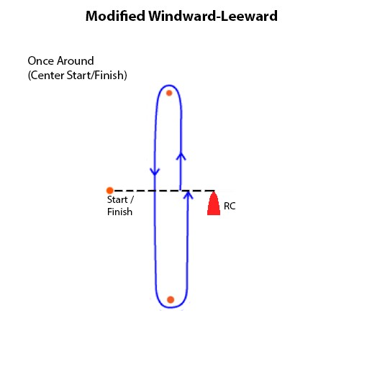

**Modified**

**ATTACHMENT A.** **COACH, SUPPORT AND SPECTATOR BOATS**

A.1 On the water, all support persons shall bring personal flotation devices which are in good condition. If the Support Boat is equipped with a Kill Cord, the driver shall be connected to it at all times the boat is underway.

A.2 Support boats are required to monitor the safety VHF channel 71 radio frequency at all times and shall be required to undertake safety duties at the direction of the Race Committee.

A.3 Coach and support boats shall communicate only by means of voice between races. Closed VHF, mobile telephone communication, communication using internet, or any other electronic or visual means of communication is prohibited.

A.4 All boats shall proceed to and from the race area under their own power.

A.5 There shall be no transfer of any goods or equipment between competitors and coach or support boats until after the finish of the last race of the day.

A.6 Coach and support boats shall not go alongside, or come in any physical contact with competitors until after the finish of the last race of the day.

A.7 Coach and support boats shall keep clear of the racing area at all times during racing.

A.8 In the event of an emergency, when the competitor has requested outside assistance, A.3 through A.7 are suspended for a Coach and/or Support Boat rendering assistance. Rendering assistance shall be reported to the Race Committee at the earliest opportunity.